1950s
1960s
1970s
1980s
1990s
2000s
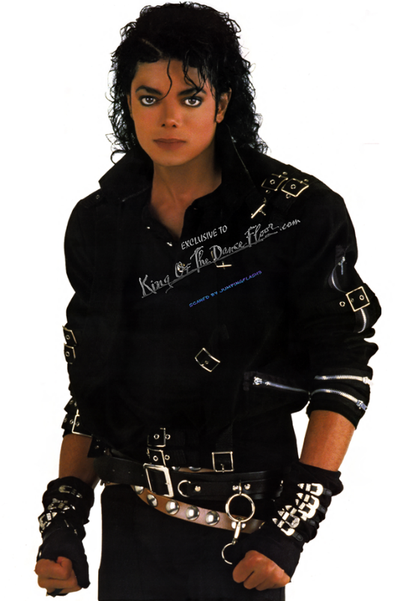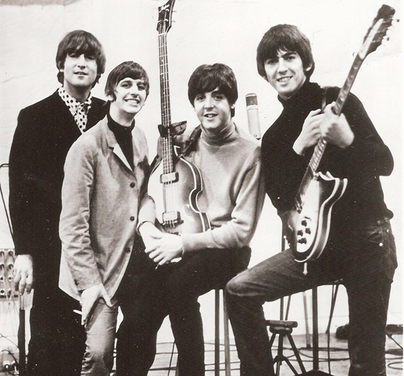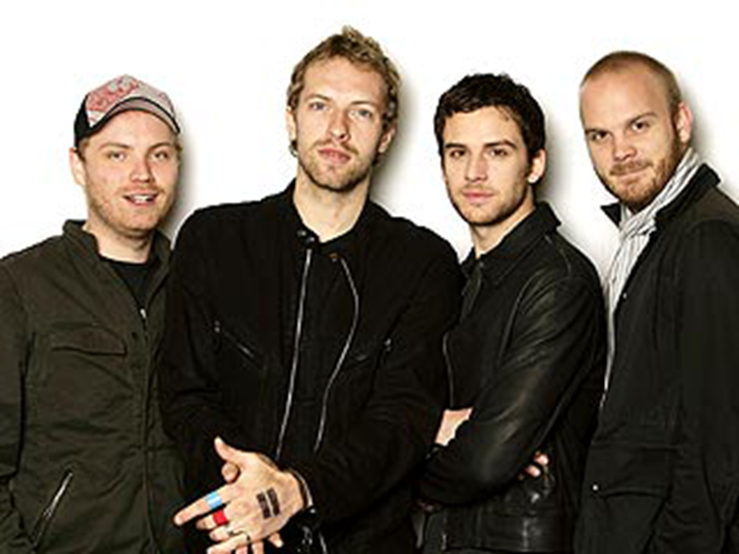
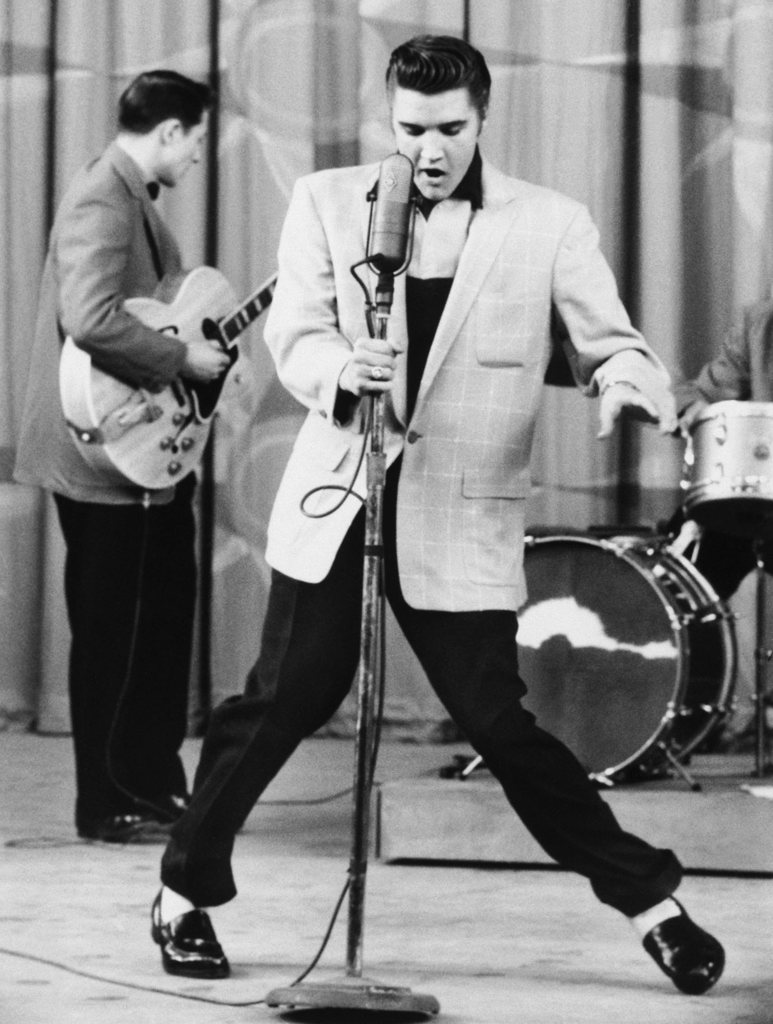

Spice Girls
Michael Jackson
Coldplay
Elvis Presley
Beatles
ABBA

As well as singing, he was also famous for his unusual dance moves and he had a lot of female admirers!
He is often called “The King of Rock and Roll”. Popular songs released in this decade include: ‘Hound Dog’ and ‘Blue Suede Shoes’.

They are from Liverpool and they have one of the most famous album covers of all time which shows them walking across a road.
They were sometimes referred to as “The Fab Four” and their fans were famous for being completely crazy about them! Popular songs from this decade include: ‘Yellow Submarine’ and ‘Love Me Do’.

They came from Sweden and were the first to win the Eurovision Song Contest for their country.
They have sold over 380 million records worldwide and popular songs released in this decade include: ‘Dancing Queen’ and ‘Mamma Mia’.
He is often referred to as “The King of Pop” and he started his career in a family band.
He has the best-selling album of all time and popular songs from this decade include: ‘Thriller’ and ‘Billie Jean’.

They had six UK number 1 hits in a row and starred in their own film.
The charts had been dominated by boybands but they introduced “Girl Power”. Their popular songs from this decade include: ‘Wannabe’ and ‘Spice up Your Life’.

They’re from London and they have won the Brit Award for Best British Group three times.
They released three of the best-selling albums of this decade and popular songs include: ‘Yellow’ and ‘Viva La Vida’.

