The Wormy Spaghetti
The next day, to pay Mr Twit back for the frog trick, Mrs Twit sneaked out into the garden and dug up some worms. She chose big long ones and put them in a tin and carried the tin back to the house under her apron.
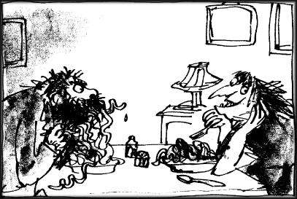
At one o’clock, she cooked spaghetti for lunch and she mixed the worms in with the spaghetti, but only on her husband’s plate. The worms didn’t show because everything was covered with tomato sauce and sprinkled with cheese.
‘Hey, my spaghetti’s moving!’ cried Mr Twit, poking around in it with his fork.
‘It’s a new kind,’ Mrs Twit said, taking a mouthful from her own plate which of course had no worms. ‘It’s called Squiggly Spaghetti. It’s delicious. Eat it up while it’s nice and hot.’
Mr Twit started eating, Twisting the long tomato-covered strings around his fork and shovelling them into his mouth. Soon there was tomato sauce all over his hairy chin.
‘It’s not as good as the ordinary kind,’ he said, talking with his mouth full. ‘It’s too squishy’
‘I find it very tasty’ Mrs Twit said. She was watching him from the other end of the table. It gave her great pleasure to watch him eating worms.
‘I find it rather bitter,’ Mr Twit said. ‘It’s got a distinctly bitter flavour. Buy the other kind next time.’
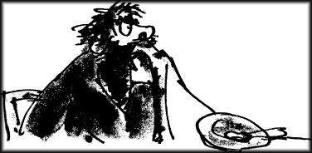
Mrs Twit waited until Mr Twit had eaten the whole plateful. Then she said, ‘You want to know why your spaghetti was squishy?’
Mr Twit wiped the tomato sauce from his beard with a corner of the tablecloth. ‘Why?’ he said.
‘And why it had a nasty bitter taste?’
‘Why?’ he said.
‘Because it was worms!’ cried Mrs Twit, clapping her hands and stamping her feet on the floor and rocking with horrible laughter.
