By the time she was three, Matilda had taught herself to read by studying newspapers and magazines that lay around the house. At the age of four, she could read fast and well and she naturally began hankering after books. The only book in the whole of this enlightened household was something called Easy Cooking belonging to her mother, and when she had read this from cover to cover and had learnt all the recipes by heart, she decided she wanted something more interesting.
‘Daddy,’ she said, ‘do you think you could buy me a book?’
‘A book?’ he said. ‘What d’you want a flaming book for?’
‘To read, Daddy.’
‘What’s wrong with the telly, for heaven’s sake? We’ve got a lovely telly with a twelve-inch screen and now you come asking for a book! You’re getting spoiled, my girl!’
Nearly every weekday afternoon Matilda was left alone in the house. Her brother (five years older than her) went to school. Her father went to work and her mother went out playing bingo in a town eight miles away. Mrs Wormwood was hooked on bingo and played it five afternoons a week. On the afternoon of the day when her father had refused to buy her a book, Matilda set out all by herself to walk to the public library in the village. When she arrived, she introduced herself to the librarian, Mrs Phelps. She asked if she might sit awhile and read a book. Mrs Phelps, slightly taken aback at the arrival of such a tiny girl unaccompanied by a parent, nevertheless told her she was very welcome.
‘Where are the children’s books please?’ Matilda asked.
‘They’re over there on those lower shelves,’ Mrs Phelps told her. ‘Would you like me to help you find a nice one with lots of pictures in it?’
‘No, thank you,’ Matilda said. ‘I’m sure I can manage.’
From then on, every afternoon, as soon as her mother had left for bingo, Matilda would toddle down to the library. The walk took only ten minutes and this allowed her two glorious hours sitting quietly by herself in a cosy corner devouring one book after another. When she had read every single children’s book in the place, she started wandering round in search of something else.
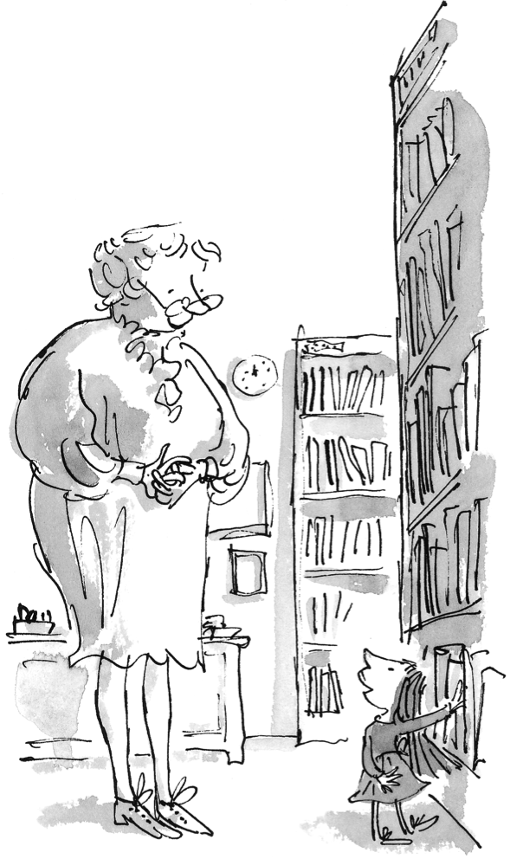
© RDSC /QB 2018
Mrs Phelps, who had been watching her with fascination for the past few weeks, now got up from her desk and went over to her.
‘Can I help you, Matilda?’ she asked.
‘I’m wondering what to read next,’ Matilda said. ‘I’ve finished all the children’s books.’
‘You mean you’ve looked at the pictures?’
‘Yes, but I’ve read the books as well.’
Mrs Phelps looked down at Matilda from her great height and Matilda looked right back up at her.
‘I thought some were very poor,’ Matilda said, ‘But others were lovely. I liked The Secret Garden best of all. It was full of mystery. The mystery of the room behind the closed door and the mystery of the garden behind the big wall.’
Mrs Phelps was stunned. ‘Exactly how old are you, Matilda?’ she asked.
‘Four years and three months,’ Matilda said.
Mrs Phelps was more stunned than ever, but she had the sense not to show it. ‘What sort of a book would you like to read next?’ she asked.
Matilda said, ‘I would like a really good one that grown-ups read. A famous one. I don’t know any names.’
Mrs Phelps looked along the shelves, taking her time. She didn’t quite know what to bring out. How, she asked herself, does one choose a famous grown-up book for a four-year-old girl? Her first thought was to pick a young teenager’s romance of the kind that is written for fifteen-year-old schoolgirls, but for some reason she found herself instinctively walking past that particular shelf.
‘Try this,’ she said at last. ‘It’s very famous and very good. If it’s too long for you, just let me know and I’ll find something shorter and a bit easier.’
‘Great Expectations,’ Matilda read, ‘by Charles Dickens. I’d love to try it.’
I must be mad, Mrs Phelps told herself, but to Matilda she said, ‘Of course you may try it.’
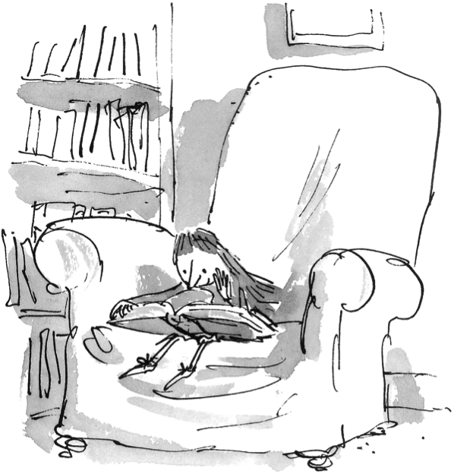
© RDSC /QB 2018
Over the next few afternoons, Mrs Phelps could hardly take her eyes from the small girl sitting for hour after hour in the big armchair at the far end of the room with the book on her lap. It was necessary to rest it on the lap because it was too heavy for her to hold up, which meant she had to sit leaning forward in order to read. And a strange sight it was, this tiny dark-haired person sitting there with her feet nowhere near touching the floor, totally absorbed in the wonderful adventures of Pip and old Miss Havisham and her cobwebbed house and by the spell of magic that Dickens the great story-teller had woven with his words. The only movement from the reader was the lifting of the hand every now and then to turn over a page, and Mrs Phelps always felt sad when the time came for her to cross the floor and say, ‘It’s ten to five, Matilda.’
During the first week of Matilda’s visits, Mrs Phelps had said to her, ‘Does your mother walk you down here every day and then take you home?’
‘My mother goes to Aylesbury every afternoon to play bingo,’ Matilda had said. ‘She doesn’t know I come here.’
‘But that’s surely not right,’ Mrs Phelps said. ‘I think you’d better ask her.’
‘I’d rather not,’ Matilda said. ‘She doesn’t encourage reading books. Nor does my father.’
‘But what do they expect you to do every afternoon in an empty house?’
‘Just mooch around and watch the telly.’
‘I see.’
‘She doesn’t really care what I do,’ Matilda said a little sadly.
Mrs Phelps was concerned about the child’s safety on the walk through the fairly busy village High Street and the crossing of the road, but she decided not to interfere.
Within a week, Matilda had finished Great Expectations which in that edition contained four hundred and eleven pages. ‘I loved it,’ she said to Mrs Phelps. ‘Has Mr Dickens written any others?’
‘A great number,’ said the astounded Mrs Phelps. ‘Shall I choose you another?’
Over the next six months, under Mrs Phelps’s watchful and compassionate eye, Matilda read the following books:
- Nicholas Nickleby by Charles Dickens
- Oliver Twist by Charles Dickens
- Jane Eyre by Charlotte Brontë
- Pride and Prejudice by Jane Austen
- Tess of the D’Urbervilles by Thomas Hardy
- Gone to Earth by Mary Webb
- Kim by Rudyard Kipling
- The Invisible Man by H. G. Wells
- The Old Man and the Sea by Ernest Hemingway
- The Sound and the Fury by William Faulkner
- The Grapes of Wrath by John Steinbeck
- The Good Companions by J. B. Priestley
- Brighton Rock by Graham Greene
- Animal Farm by George Orwell
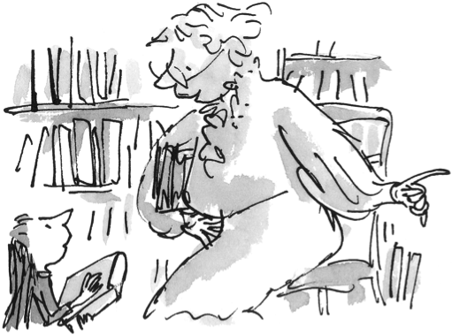
© RDSC /QB 2018
It was a formidable list and by now Mrs Phelps was filled with wonder and excitement, but it was probably a good thing that she did not allow herself to be completely carried away by it all. Almost anyone else witnessing the achievements of this small child would have been tempted to make a great fuss and shout the news all over the village and beyond, but not so Mrs Phelps. She was someone who minded her own business and had long since discovered it was seldom worth while to interfere with other people’s children.
‘Mr Hemingway says a lot of things I don’t understand,’ Matilda said to her. ‘Especially about men and women. But I loved it all the same. The way he tells it I feel I am right there on the spot watching it all happen.’
‘A fine writer will always make you feel that,’ Mrs Phelps said. ‘And don’t worry about the bits you can’t understand. Sit back and allow the words to wash around you, like music.’
‘I will, I will.’
‘Did you know,’ Mrs Phelps said, ‘that public libraries like this allow you to borrow books and take them home?’
‘I didn’t know that,’ Matilda said. ‘Could I do it?’
‘Of course,’ Mrs Phelps said. ‘When you have chosen the book you want, bring it to me so I can make a note of it and it’s yours for two weeks. You can take more than one if you wish.’
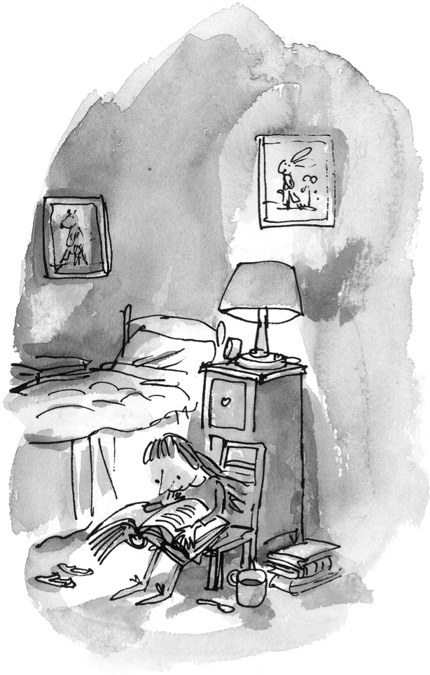
© RDSC /QB 2018
From then on, Matilda would visit the library only once a week in order to take out new books and return the old ones. Her own small bedroom now became her reading-room and there she would sit and read most afternoons, often with a mug of hot chocolate beside her. She was not quite tall enough to reach things around the kitchen, but she kept a small box in the outhouse which she brought in and stood on in order to get whatever she wanted. Mostly it was hot chocolate she made, warming the milk in a saucepan on the stove before mixing it. Occasionally she made Bovril or Ovaltine. It was pleasant to take a hot drink up to her room and have it beside her as she sat in her silent room reading in the empty house in the afternoons. The books transported her into new worlds and introduced her to amazing people who lived exciting lives. She went on olden-day sailing ships with Joseph Conrad. She went to Africa with Ernest Hemingway and to India with Rudyard Kipling. She travelled all over the world while sitting in her little room in an English village.

