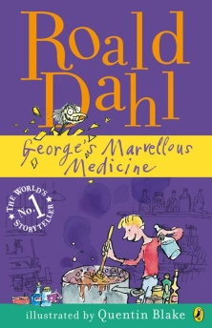
Chapter 1: Grandma

Read through Chapter 1 and answer the following questions

1. What did George’s mother say she was going to do?
___________________________________________

2. What did George’s mum tell him not to forget? _____________________________________________

3. “Get me some tea” Grandma told George. “And __________________________________________,”

4. What did Grandma say George’s problem was?
_____________________________________________

5. What was Grandma’s advice to George?

“You should stop __________________________ and _________________________________________,”

6. What did George think about his Grandma’s advice?
____________________________________________________________________________________________________________________________________________________________

