

Week beginning Monday 4th May 2020
Year 6
Literacy  There are 5 comprehension tasks on the Year 6 website this week. Try to complete one a day this week.  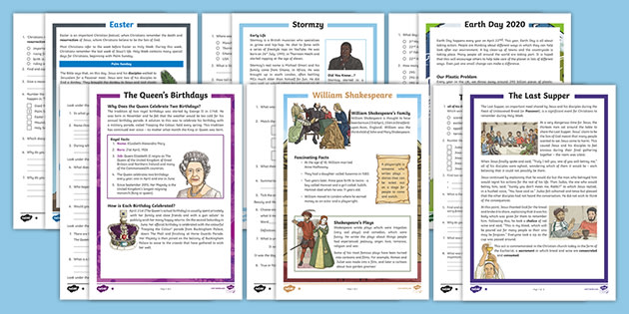 | Numeracy  In numeracy you would have been learning about how to calculate the area of parallelograms and triangles.  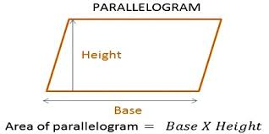  Read the presentation and complete the activities.
Science
In this half term we are going to learn about a different famous scientist each week. This week is Marie Maynard Daly. Look through the presentation to learn about her and her achievements and then complete the 2 activities related to her.
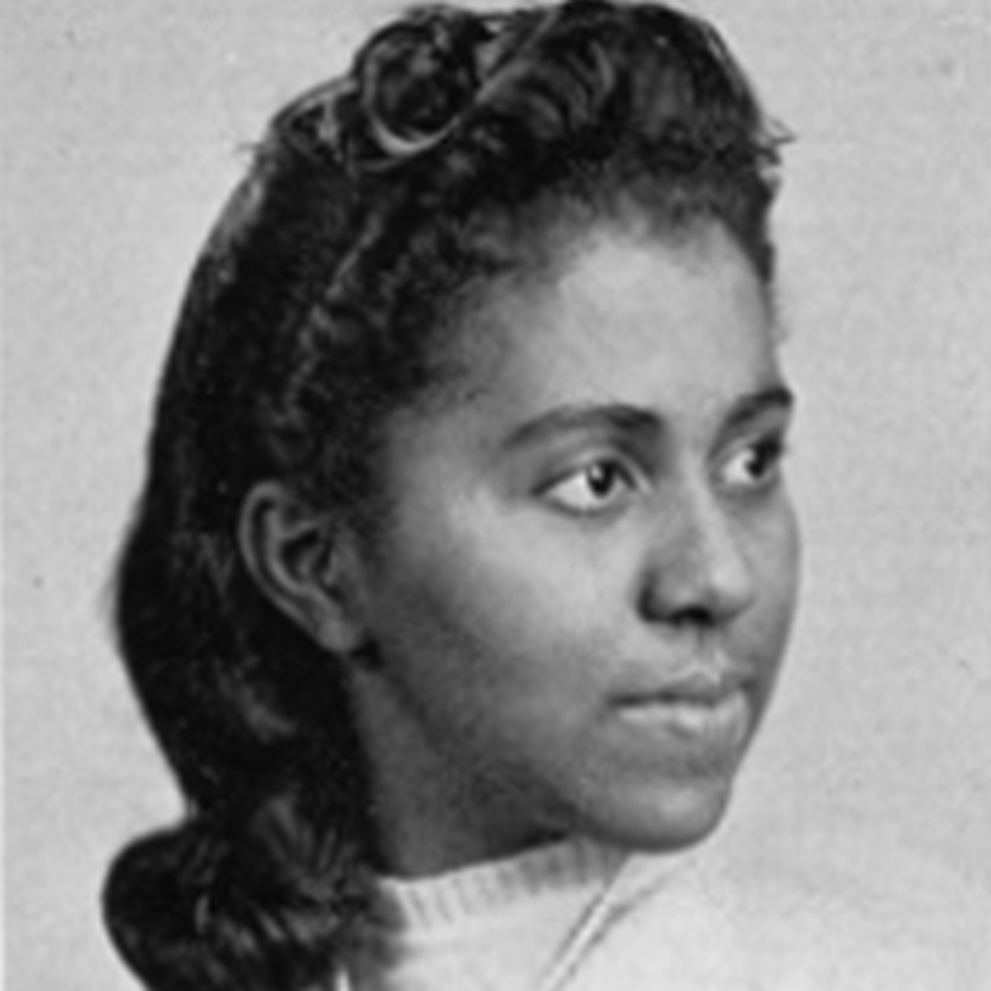
Thematic
This week in our ‘Magnificent Mayans’ topic we should be learning about the Mayan number system.
Read the presentation about the Mayan number system and then complete the associated tasks.
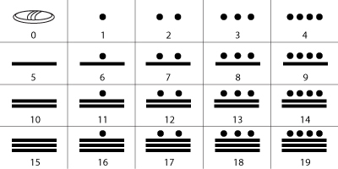
Art
The Mayans carved many intricate patterns and sculptures out of stone. This is one of their most famous sculptures – it is actually an ancient calendar! Do some research about Mayan calendars and try colouring the print out of this pattern.
https://www.dkfindout.com/uk/history/mayans/mayan-calendar/


