

Week beginning Monday 20th July 2020
Year 6
Literacy
Normally in Year 6 at the end of the year, we get a chance to share our memories of our time at Gayton with each other – we sometimes even share these in a special assembly. As we are missing out on this, it would be wonderful if you could write to us and let us know what your favourite things about Gayton have been – try to remember the trips, the treats, the visitors, special days and the amazing lessons. Is there one lesson or topic that stands out? Is there something funny that you will never forget? What are you most proud of yourself for achieving?
Please email your letter to your class teacher (or to me!)
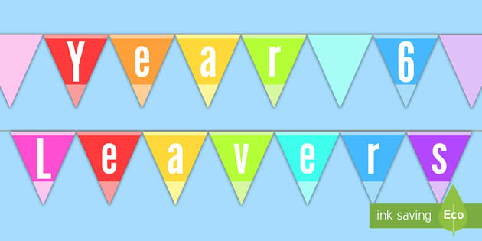
Numeracy
Have a go at the Year 7 maths transition pack. This will give you an idea of the level of work expected of you in Year 7 and will help you identify any areas you might need to practise before you move up to secondary school.
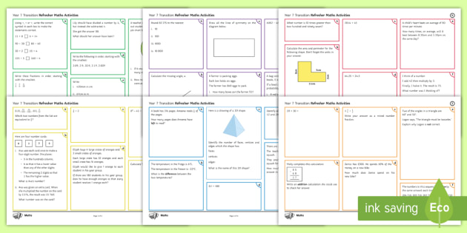
Art
Have a go at following the origami instructions to make a butterfly and a crane.
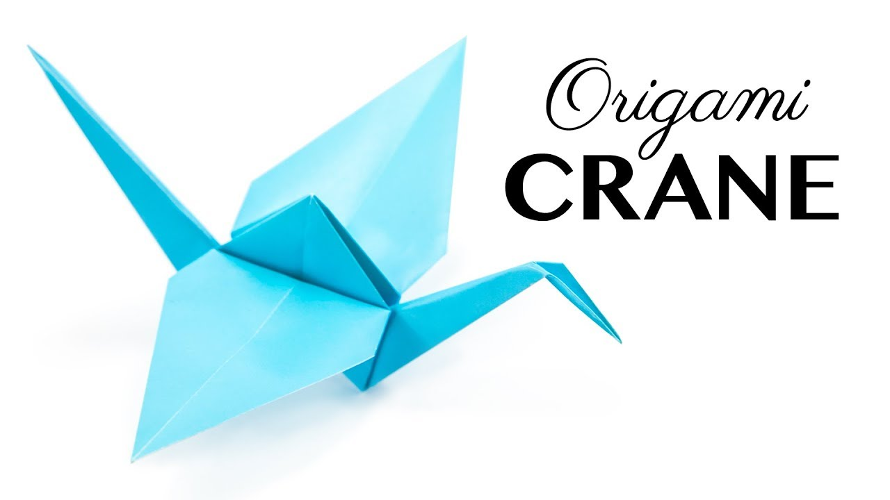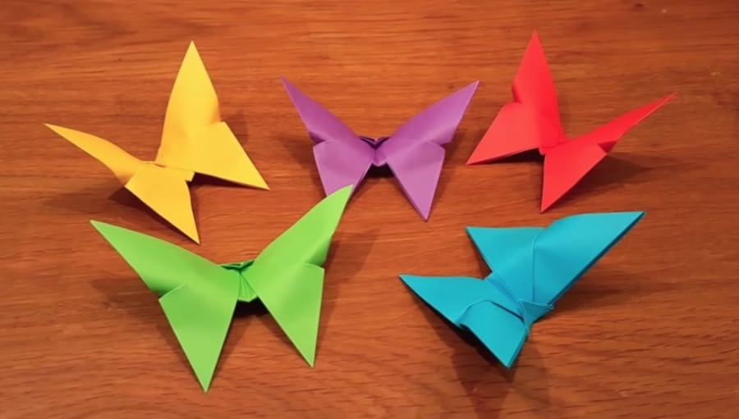
Pastime Passion Project
At the end of the year we like to give the children an opportunity to create their own project about something they are passionate about – a hobby, sport, movie, game, singer etc. You can present your passion project in any way you want but we normally suggest you produce some form of leaflet/booklet/presentation and a piece of artwork. What is your passion?
We would love to see your project so please email it (or a photo of it) to your class teacher (or to me!)
ltrimbee@gaytonj.derby.sch.uk
echapman@gaytonj.derby.sch.uk
nkettle@gaytonj.derby.sch.uk
dodonnell@gaytonj.derby.sch.uk


