

Week beginning Monday 13th July 2020
Year 6
The War of the Worlds
The War of the Worlds is a novel by H.G. Wells in which Martians invade Earth. It was written over 100 years ago.
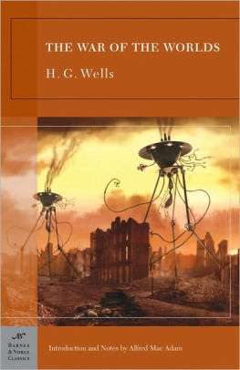
Literacy
Read the extract and answer the comprehension questions.
Literacy
Imagine a UFO crash-landed on the field at Gayton! Write a short story about what would happen next…
Maths
Complete the ‘mystery of the pilfered penguins’ activity!
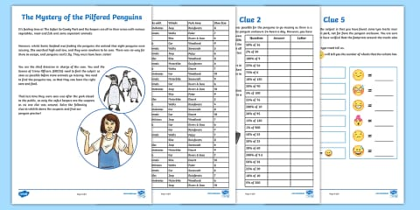
Art
Draw a picture of what you think the Martian looked like from the description in the extract.
Film
The children in school this week are creating and making a monster!
Look at the examples on the monsters sheet and then draw a new monster. Give it a name, describe what it sounds like, moves like, what it likes to eat etc, etc!


