

Week beginning Monday 8th June 2020
Year 5
Literacy  Last week you read The Highwayman by Alfred Noyes. This week complete the SPAG activities related to the story.  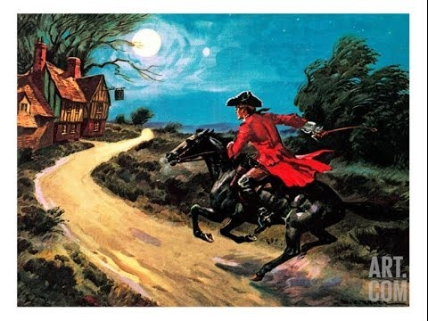 | Numeracy  In numeracy you would have been developing our understanding of calculating area.  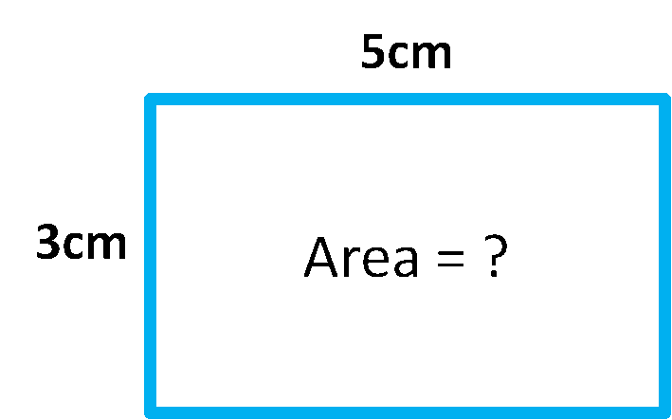  There are 2 presentations about area. Read through 1 and do the differentiated task, then read through the second and complete task 2.
Spellings
Year 5 Summer week 7:
Bully, Fully, Above, Love, Glove, Beautiful, Careful, Understand, Abrupt, Difficult, Govern, Lovable 
Science
Each week this half term you will be learning about a famous scientist or inventor. This week it is Eva Crane. Read the presentation about her and then complete the activity about her life.
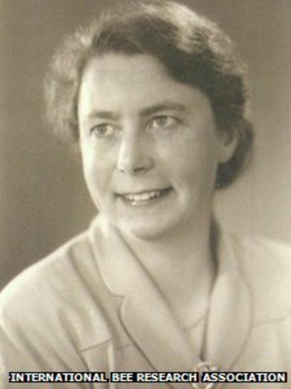
Thematic
For the last half term of the year we should be learning about the Tudors.
When Henry VIII died, his 9 year old son, Edward became king of England - Edward VI – the boy king.
Read the presentation about him and then complete the differentiated activity sheet to show your understanding of Edward’s life.
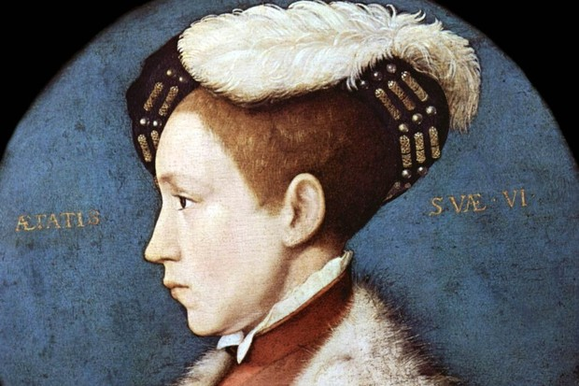
Art
Eva Crane highlighted the fact that bee numbers were declining. In order to prevent the bee population from falling further, we can create bee hotels in our gardens. Many bee species nest in tiny spaces ranging from hollow plant stems to holes in deadwood or bare ground. Bee hotels consist of a number of hollow tubes. They mimic the conditions suitable for bees that nest above ground in stems and holes.
Try to create a ‘bee hotel’ in your garden. There are lots of examples and instructions on the internet – just google: how to make a bee hotel


