

Week beginning Monday 27th April 2020
Year 5
Literacy  As part of our Shakespeare unit, this week you should be reading The Tempest by William Shakespeare.  Follow the link on the website to read a summary of the story.  Create a front cover and back blurb for a book of The Tempest.  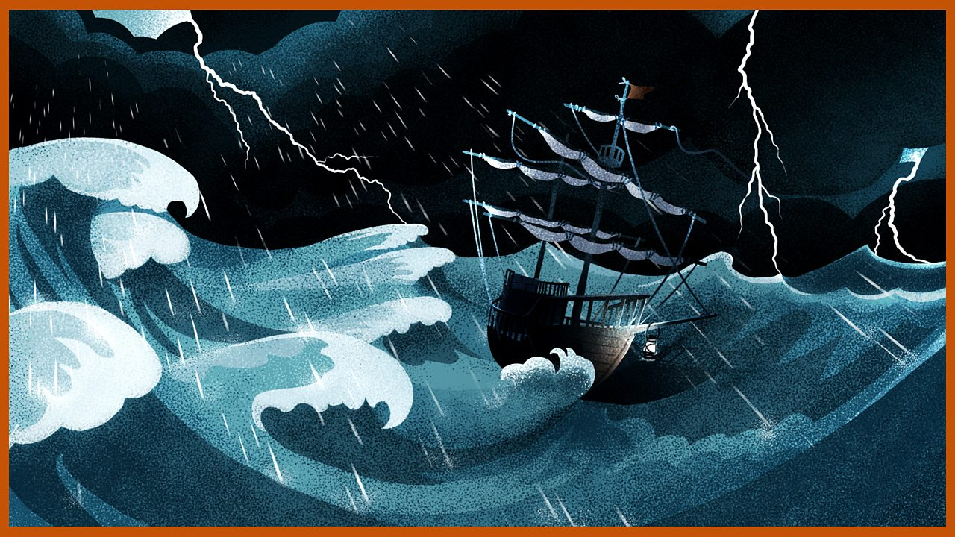 | Numeracy  In numeracy you would have been working on time problems.    Complete the time worksheets.
Spellings
Year 5 Summer week 2:
Words that contain an ‘oo’ sound.
Spoon, Groom, Crew, Blue, Glued, Bloomed, Threw, Through, Pursue, Cartoon, Typhoon, Groomed

Science
This week we should be learning about how materials insulate.
Have a look through the presentation and complete the associated tasks.

Thematic
This week we should be learning about William the Conqueror.
Look at the presentation about William and then create a mindmap or poster about what you know about him.
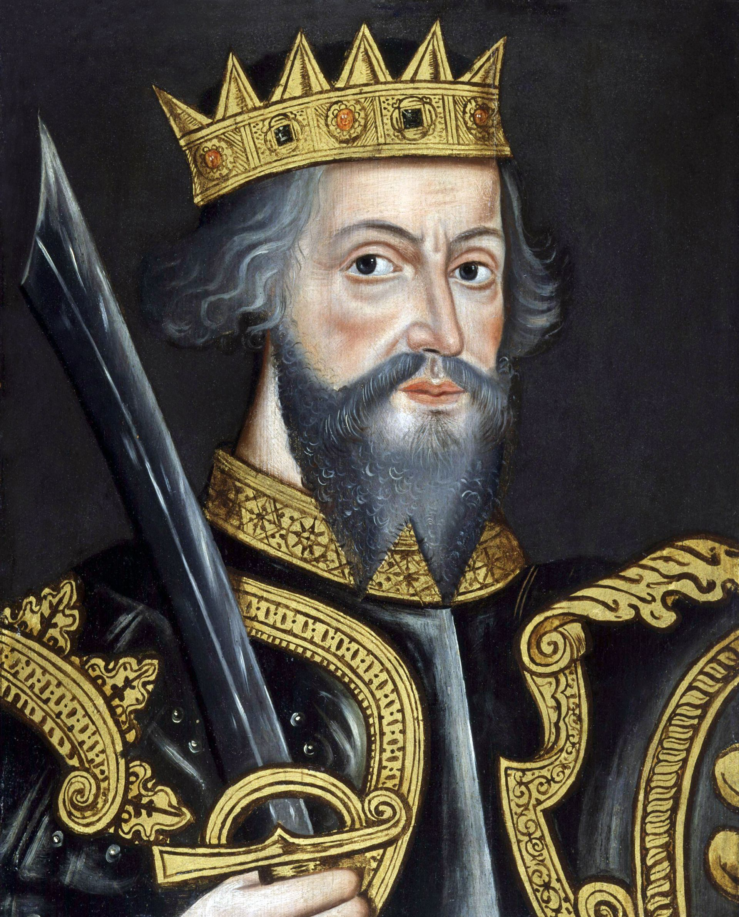
Art
This half term Year 5 are meant to be investigating portraits.
Using the skills learnt last week, draw a portrait of William the Conqueror or William Shakespeare.


