

Week beginning Monday 20th July 2020
Year 5
Literacy
Watch a short film called The Lighthouse at Literacy Shed.
There is a pack of activities that you can do linked to the film, such as a comprehension task, wordsearch, poetry writing, artwork and maths challenges.
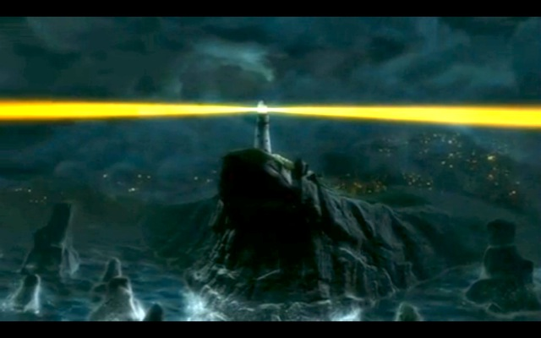
Numeracy
Complete the Mystery of the Burgled Bangers activity to find out which dog stole the sausages!
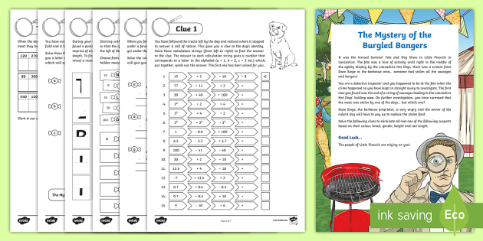
Art
Have a go at following the origami instructions to make a butterfly and a crane.
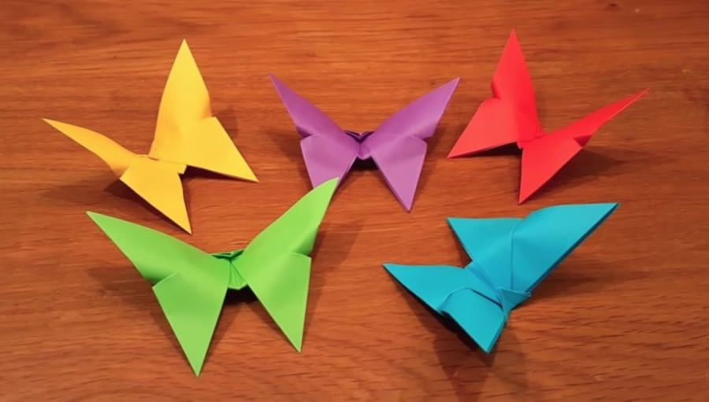
Pastime Passion Project
At the end of the year we like to give the children an opportunity to create their own project about something they are passionate about – a hobby, sport, movie, game, singer etc. You can present your passion project in any way you want but we normally suggest you produce some form of leaflet/booklet/presentation and a piece of artwork. What is your passion?
We would love to see your project so please email it (or a photo of it) to your class teacher (or to me!)
rgallagher@gaytonj.derby.sch.uk
pevans@gaytonj.derby.sch.uk
lodonnell@gaytonj.derby.sch.uk
dodonnell@gaytonj.derby.sch.uk


