

Week beginning Monday 15th June 2020
Year 5
Literacy  This week we would be looking at inference of the text and character relationships. Read the presentation and complete the activity.  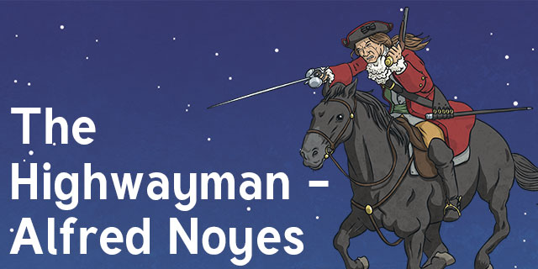 | Numeracy  In numeracy you would have been developing our understanding of calculating perimeter.  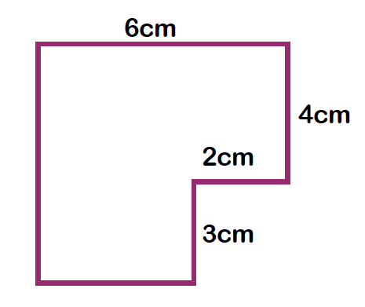  There is a presentation and activity about measuring perimeter and also a mastery presentation and activity if you want a challenge!
Spellings
Year 5 Summer week 8: ible and able words
Horrible, Possible, Comfortable, Adorable, Legible, Forcible, Applicable, Reliable,
Incredible, Considerable, Tolerable, Dependable

Science
Each week this half term you will be learning about a famous scientist or inventor.
This week it is Stephanie Kwolek. Read the presentation about her and then complete the experiment activity.

Thematic
For the last half term of the year we should be learning about the Tudors.
This week you would be learning about the bloody reign of Mary Tudor.
Read the presentation about her and then complete the differentiated activity sheet.
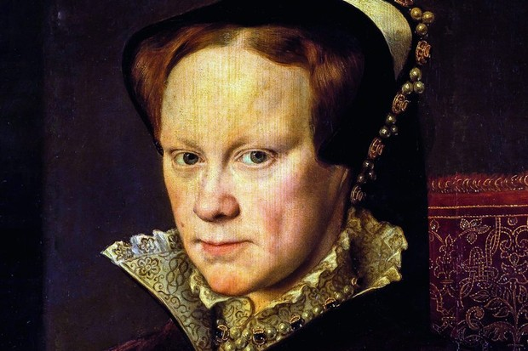
Art
The Highwayman poem is full of beautiful imagery. The poem starts with:
The wind was a torrent of darkness among the gusty trees
The moon was a ghostly galleon tossed upon cloudy seas
The road was a ribbon of moonlight over the purple moor
The Highwayman came riding, up to the old inn door.
Can you create a piece of artwork that depicts the start of the story?


