

Week beginning Monday 20th April 2020
Year 4
Literacy  This week in literacy you would have been learning about adventure stories.  Adventure stories often include:  Something exciting and extraordinary, often a quest or a mission. Escaping danger, going on a quest or experiencing something out of the ordinary.  Examples of famous adventure stories are the Famous Five adventures, Gulliver’s Travels, Kensuke’s Kingdom, Journey to The Centre of the Earth and 20,000 Leagues Under the Sea.  Use the resources to write an adventure story of your own.  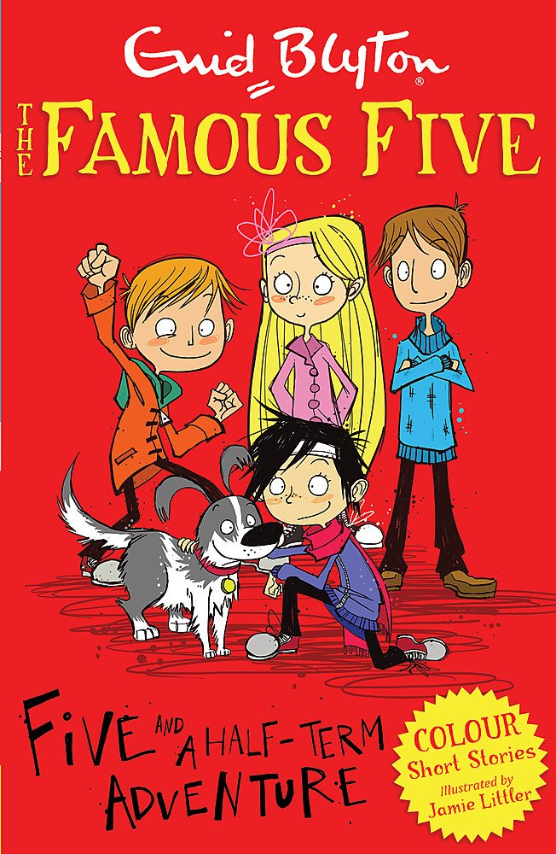 | Numeracy  In numeracy you would have been learning about place value. This is the value of each digit in a number.  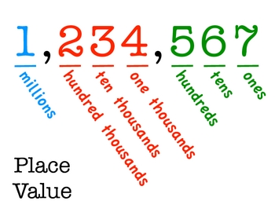  Complete the tasks on place value.
Spellings
Summer week 1:
Words ending in the pattern ‘ion’.
Invention, Relation, Mention, Solution, Injection, Station, Position,
Protection, Separation, Hesitation, Completion, Distinction
Miss Lloyd’s group should be learning the following words:
July, why, fly, spy, apply, supply, deny, rely, identify, magnify, multiply, crucify
Science
Our science topic this half term is Habitats.
Look at the lesson using the link and complete the associated tasks over the next few weeks.
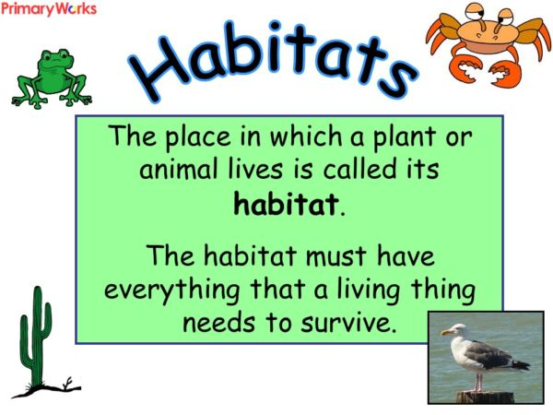
Thematic
Our topic for the next 5 weeks is ‘How does Derby compare?’. This week we should be learning about the counties of England and specifically which counties are in the East Midlands. Do some research about counties and try to memorise as many as you can. There are some links on the website which might help you and the grown ups at home with this task.


