

Week beginning Monday 20th July 2020
Year 4
Literacy
Watch a short film called The Lighthouse at Literacy Shed
There is a pack of activities that you can do linked to the film, such as a comprehension task, wordsearch, poetry writing, artwork and maths challenges.
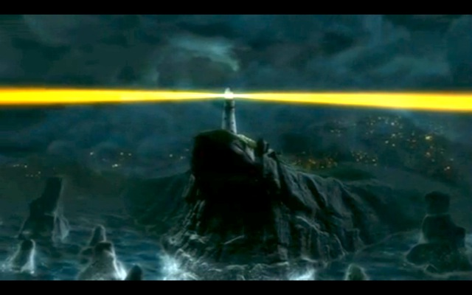
Numeracy
It is essential that you know your times tables. So much of the Year 5 maths curriculum uses times table recall. Please practise your tables over the summer. At the very least, you should be able to recite all the tables – even if you don’t know them instantly.
Complete the times tables activities – you could even stick the times table wheel up by your bed to help you practise them each night.
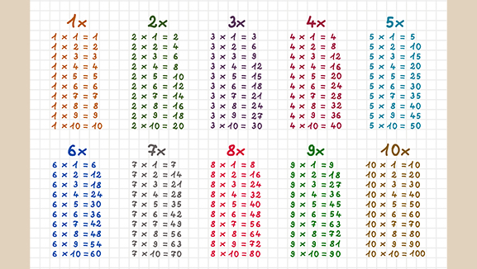
Art
Have a go at making a desk tidy from the templates provided.

Pastime Passion Project
At the end of the year we like to give the children an opportunity to create their own project about something they are passionate about – a hobby, sport, movie, game, singer etc. You can present your passion project in any way you want but we normally suggest you produce some form of leaflet/booklet/presentation and a piece of artwork. What is your passion?
We would love to see your project so please email it (or a photo of it) to your class teacher (or to me!)
elloyd@gaytonj.derby.sch.uk
khallam@gaytonj.derby.sch.uk
raujla@gaytonj.derby.sch.uk
dodonnell@gaytonj.derby.sch.uk


