

Week beginning Monday 18th May 2020
Year 4
Literacy  There are 5 reading activities on the website. Complete 1 a day. There are 3 differentiated levels for each text – choose the correct level for yourself.  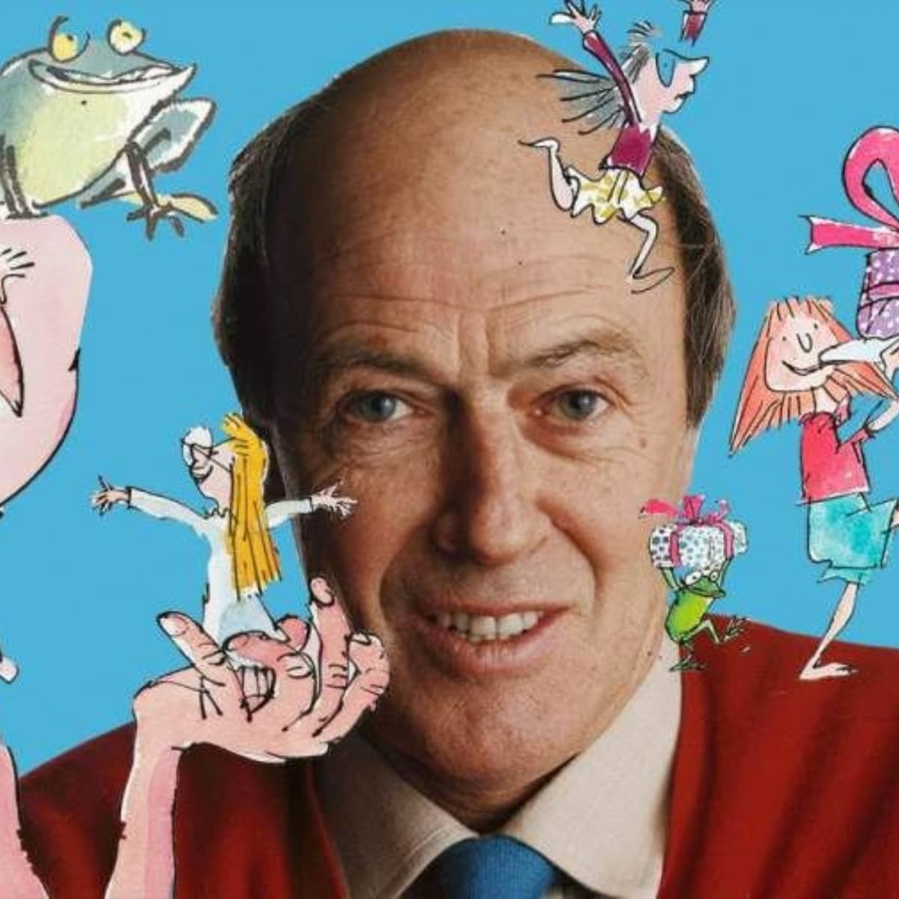  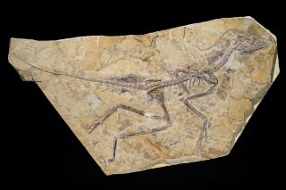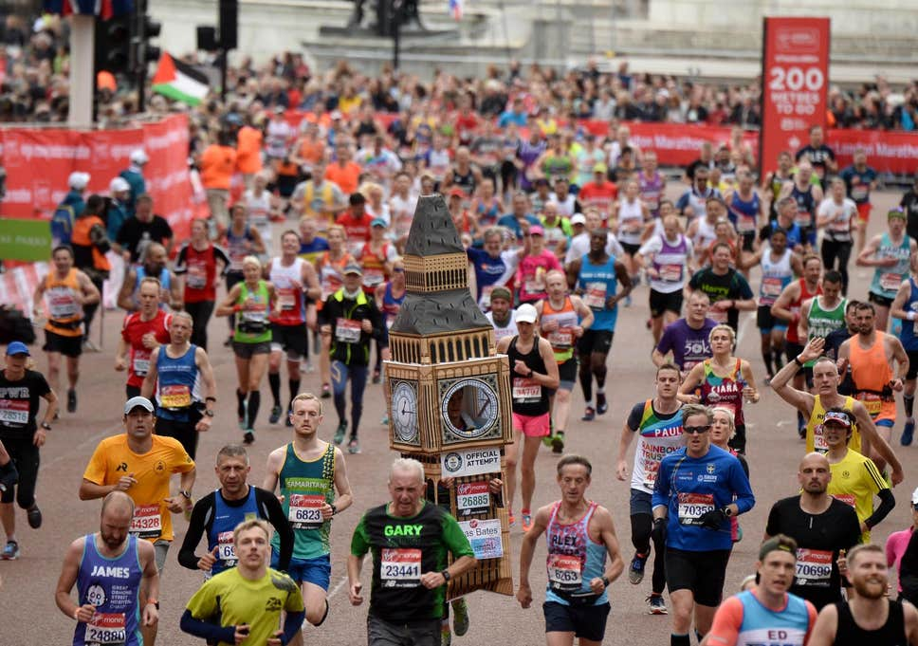 | Numeracy  In numeracy you would have been working on symmetry.    Complete the lines of symmetry worksheet.
Spellings
Summer week 5: Homophones (words that sound the same but mean different things)
There, Their, Mane, Main, Break, Brake, Night, Knight, Allowed, Aloud, Guessed, Guest
Miss Lloyd’s group should be learning the following words:
Work, Word, World, Wore, Worth, Sworn, Worse, Worst, Worthless, Worsening, Workhouse, Worldly
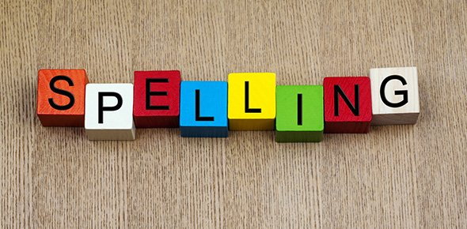
Science
Our science topic this half term is Habitats.
This week you should be learning about environmental change.
Have a look at the presentation and complete the associated tasks.

Thematic
This week we should be learning about how London has changed through history.
Read the presentation about London and complete the activity sheet.

Art and DT
This half term we have learnt about Britain and British wildlife. To conclude the topic, create a ‘bug hotel’ in your garden or create a piece of artwork of wildlife you have seen where you live.
https://schoolgardening.rhs.org.uk/resources/project/make-a-bug-hotel


