

Week beginning Monday 13th July 2020
Year 4
Literacy  There are 5 comprehension tasks about inspirational people. Perhaps do one a day. There is one about Marcus Rashford, one about Greta Thunberg, one about Michelle Obama, one about Stephen Hawking and one about Martin Luthor King.   | Numeracy  Complete the Chocolate factory mystery activity.  Work out the clues to find who the thief is!  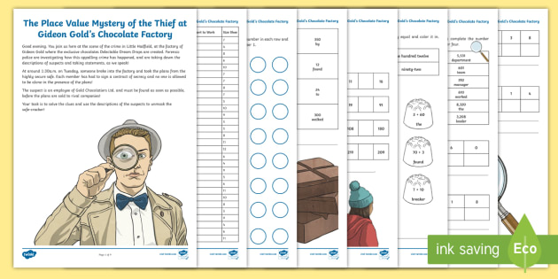
Spellings
Summer week 12:
Circle, Earth, Island, Interest, Address, Certain, Increase, Possible, Experience
Century, Accident, Knowledge
Miss Lloyd’s group should be learning the following words:
Where, White, Wheel, Photo, While, Graph, Alphabet, Whenever, Whereas, Phrase, Nephew, Whistle
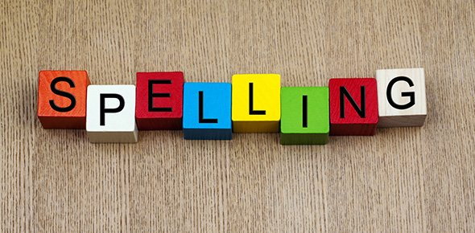
Science
To conclude our ‘scientists and inventors’ unit we are going to look at where in the world certain inventions came from. Print out the inventions sheet and stick the inventions to where you think they were invented THEN read the PowerPoint to check whether you were right!
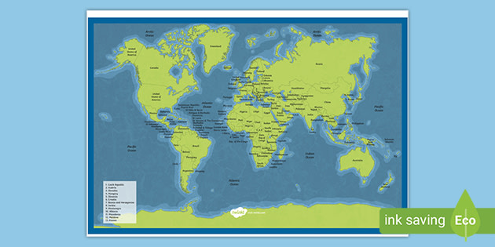
Thematic
To conclude our Britain since 1950 topic, we would be looking at what things might be like in the future.
Hopefully you have seen how much things have changed over the last 70 years. What do you think the world will be like when you are a grandparent in about 70 years?!
Create a mindmap about what clothes, cars, schools and technology might be like in the future!

Art and DT
Choose one of your future ideas from the box above and draw and annotate it in detail.
You could design a future car, future fashion, future technology or something completely new!


