

Week beginning Monday 8th June 2020
Year 3
Literacy  This half term we would have been looking at different Roald Dahl texts.  This week we would have been reading George’s Marvellous Medicine – my personal favourite Roald Dahl book!  It is a story that follows the misadventures of George in attempting to make a medicine to make his Grandma a nicer person!  Read Chapter 1 and answer the comprehension questions.  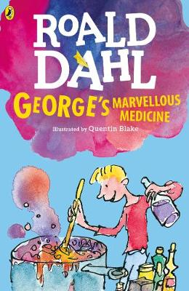 | Numeracy  In numeracy you would have been learning about ordering fractions..  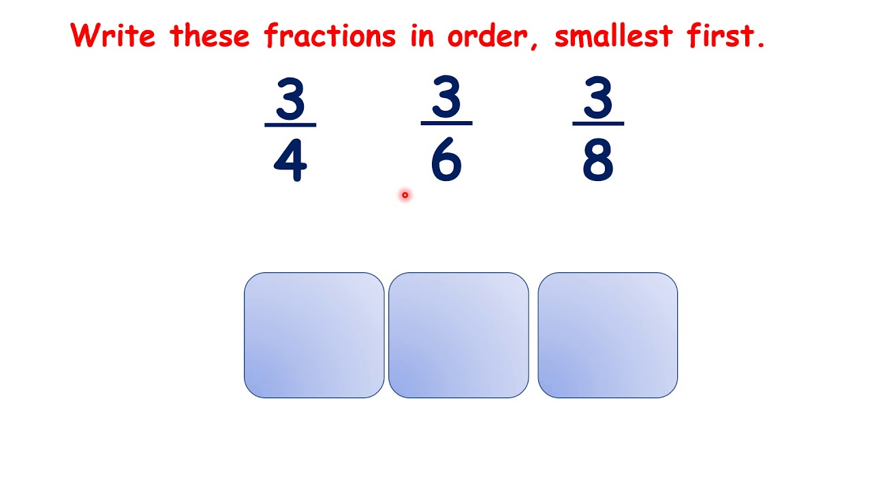  Look through the presentation and then complete the differentiated fractions activity sheets.
Spellings
Miss Barfield and Mr Dawson’s groups should be learning Week 7’s words:
Basement, Payment, Placement, Enjoyment, Development, Arrangement, Settlement, Amazement, Government,
Argument, Disappointment, Involvement
Mrs Orchard’s group should be learning these homophones:
there, their, they’re, where, wear, to, too, two, write, right
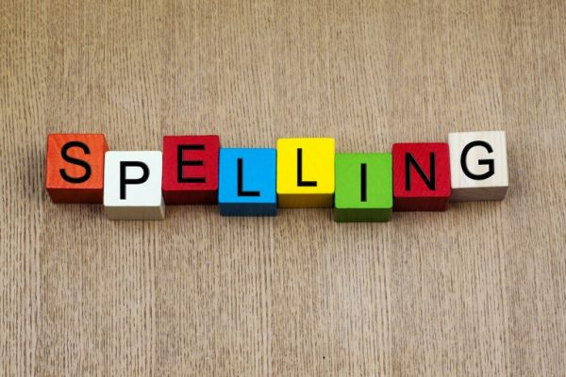
Science
Each week this half term we will be learning about a famous scientist or inventor.
This week we are going to learn about Marie Curie.
Read the presentation about her and then complete the activity sheets.
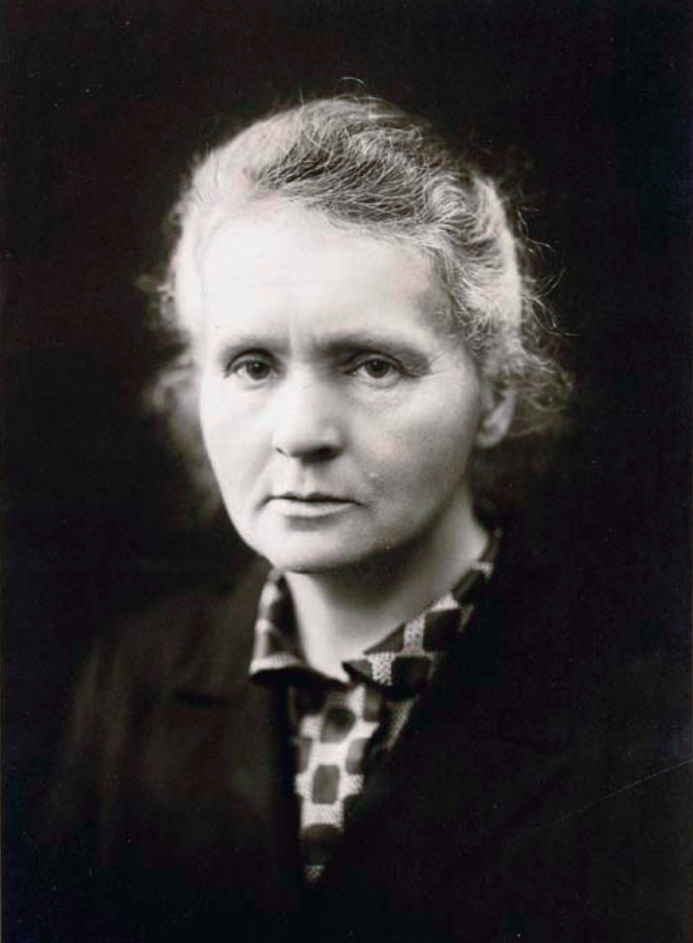
Thematic
This week we would have been learning about the boroughs of Derby as part of our Littleover and Beyond topic.
Derby is divided up into 17 wards. Littleover is one of these ‘wards’.
Abbey, Allestree, Alvaston, Arboretum, Blagreaves, Boulton, Chaddesden, Chellaston, Darley, Derwent, Littleover, Mackworth, Mickleover, Normanton, Oakwood, Sinfin, Spondon
Try to place the different wards on the blank map of Derby.
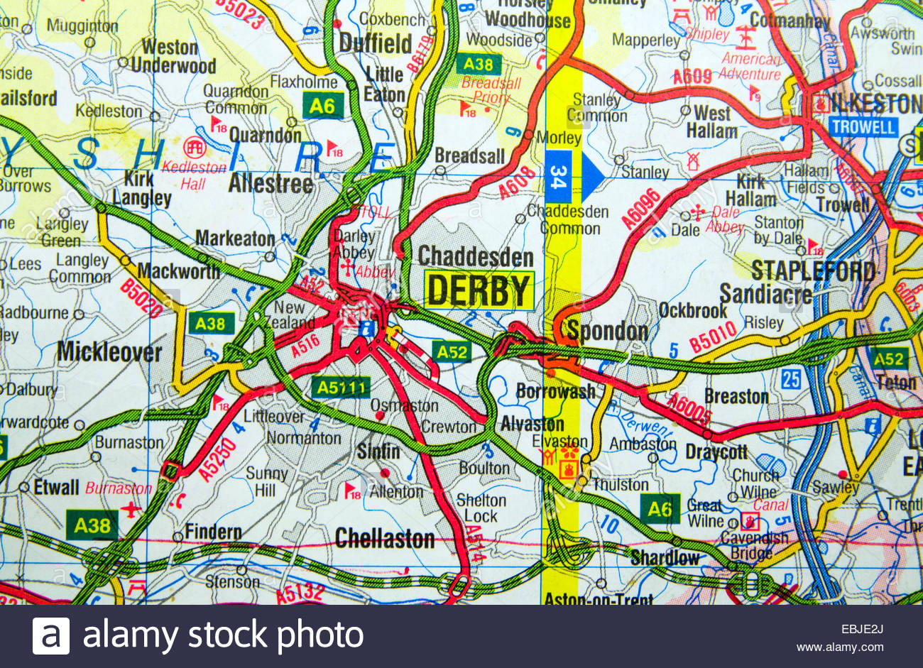
Art
Seurat was famous for using painting with a style known as pointillism.
Look through the presentation about pointillism and then colour in the blank Seurat painting using his technique.


