

Week beginning Monday 20th April 2020
Year 3
Literacy  This week in literacy you would have been learning about the features of play scripts.  A play script is a piece of writing written for the stage.  - A play script will include a list of characters (at the very beginning).  - It may be divided into acts which are then divided into scenes.  - Each scene will have a description of the setting at the start and then the characters' dialogue.  - Dialogue is set out with the character's name on the left, then a colon then the dialogue (without speech marks).  - Stage directions for the actors are written every now and again in italics and brackets.  Read the Little Red Riding Hood play script and then turn text from the story into a play script. | Numeracy  In numeracy you would have been learning about place value. This is the value of each digit in a number.  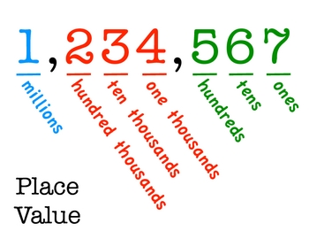  Complete the tasks on place value.
Spellings
Miss Barfield and Mr Dawson’s groups should be learning Week 1’s words:
July, why, fly, spy, apply, supply, deny, rely, identify, magnify, multiply, crucify
Mrs Orchard’s group should be learning the high frequency words:
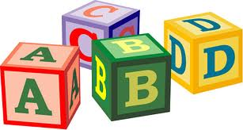
window, trees, hard, white, why, sleep, cried, really, keep, morning
Science
Our science topic this half term is Light and Shadow.
This week you should be learning about what light actually is.
Look through the Light and Shadows PowerPoint and then have a go at the tasks.

Thematic
In our Rocking Romans topic this week you would have learnt about Boudicca and her revolt against the Romans. Do some research about Boudicca and create a poster/mindmap about her life and what she achieved.
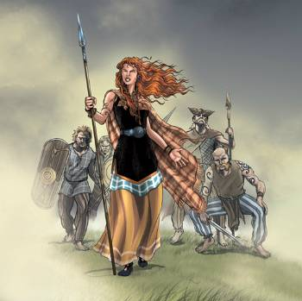
Art
This term we should be looking at the work of one of Britain’s most important and famous artists – L.S. Lowry. Do some research about Lowry – look at his artwork and identify the features of his work – what do most of his paintings have in common?


