

Week beginning Monday 15th June 2020
Year 3
Literacy  This half term we would have been looking at different Roald Dahl texts.  This week we would have been reading Charlie and the Chocolate Factory – probably Roald Dahl’s most famous book.  It is a story of a young boy called Charlie and four other kids who win a tour of an amazing chocolate factory run by an imaginative chocolatier, Willy Wonka, and his staff of Oompa-Loompas!  Read the extract describing Willy Wonka – notice the use of adjectives and similes to help the reader picture the character.  Try to write a description of your mum or dad in the style of Roald Dahl – use lots of adjectives to describe what they are wearing and use similes to describe how they move and speak!  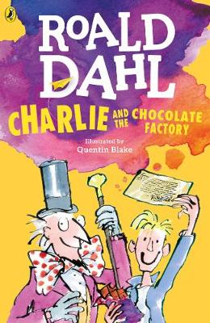 | Numeracy  In numeracy you would have been learning about perimeter.  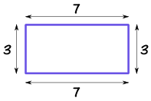  Read the presentation about perimeter and then complete the differentiated perimeter activity sheets. There is also a mastery challenge if you feel brave!
Spellings
Miss Barfield and Mr Dawson’s groups should be learning Week 8’s words:
Illness, Darkness, Sickness, Madness, Witness, Weakness, Kindness, Fairness, Business,
Awareness, Forgiveness, Loneliness
Mrs Norchi’s group should be learning these homophones:
See, sea, blue, blew, ate, eight, buy, bye, hour, our

Science
Each week this half term we will be learning about a famous scientist or inventor.
This week you will be learning about George Washington Carver.
Read the presentation about him and then complete the Growing Crops activity sheet.
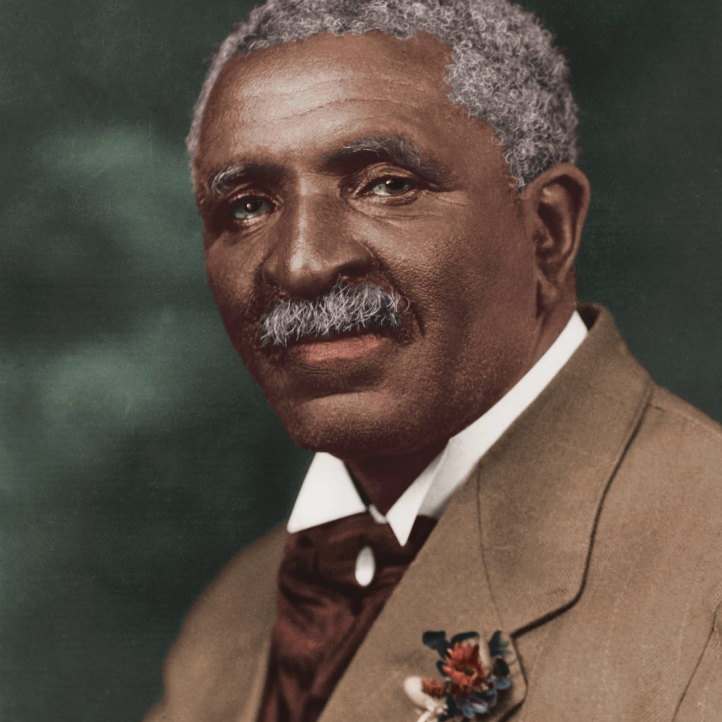
Thematic
This week we would have been learning about the history of Derby in our Littleover and Beyond topic.
Read the Wikipedia pages about Derby and then create a mindmap about Derby.
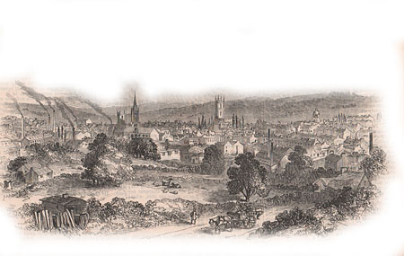
Art
Over the past few weeks we have been learning about Seurat and his style of painting called pointilism. This week draw a small picture and colour it using pointalism – remember to mix colours on the paper e.g. make green grass by placing yellow and blue dots together; make purple by placing red and blue dots next to each other etc.


