

Week beginning Monday 1st June 2020
Year 3
Literacy  This half term we would have been looking at different Roald Dahl texts.  This week we would have been reading The Twits. If you have a copy of the book, you could try reading the whole thing over the week (it’s not very long!).  Read the extracts called Mrs Twit gets a Stretching and Mrs Twit goes ballooning and answer the comprehension questions.  There is another extract called Wormy Spaghetti. Read that and create a prank that Mr Twit could play on Mrs Twit in revenge!  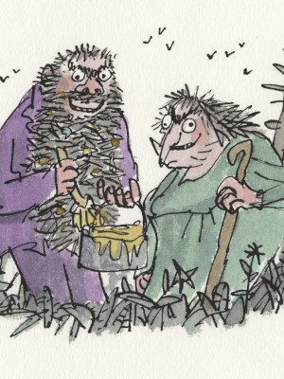 | Numeracy  In numeracy you would have been learning about missing number problems.  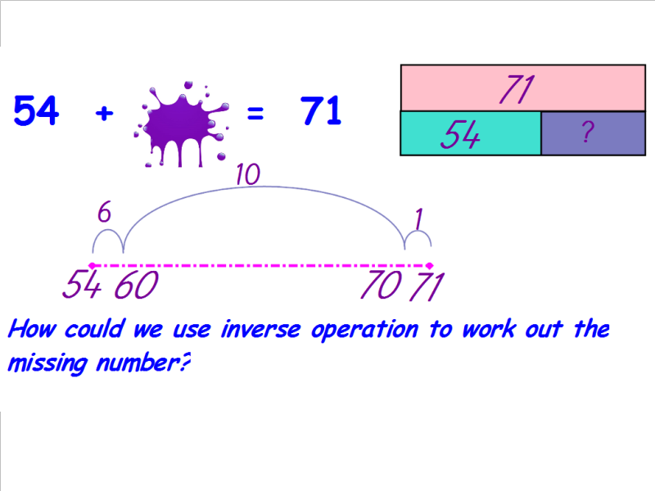  Complete the differentiated activity sheets.
Spellings
Miss Barfield and Mr Dawson’s groups should be learning Week 6’s words:
War, Warm, Ward, Award, Towards, Forward, Warden, Dwarf, Afterwards, Rewarded, Swarming, Thwart
Mrs Orchard’s group should be learning the high frequency words:
key, run, best, park, grow, who, what, when, why, where
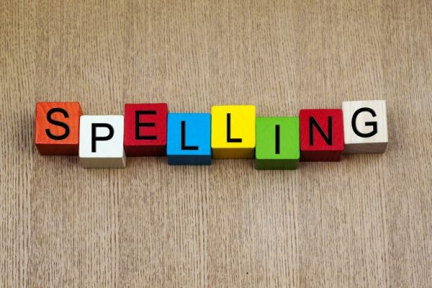
Science
Each week this half term we will be learning about a famous scientist or inventor.
This week we are going to learn about Joseph Banks and other famous botanists.
Read the presentation about ‘Plant Hunters’ and then complete the plant hunters activity sheet and the new discovery activity sheet.
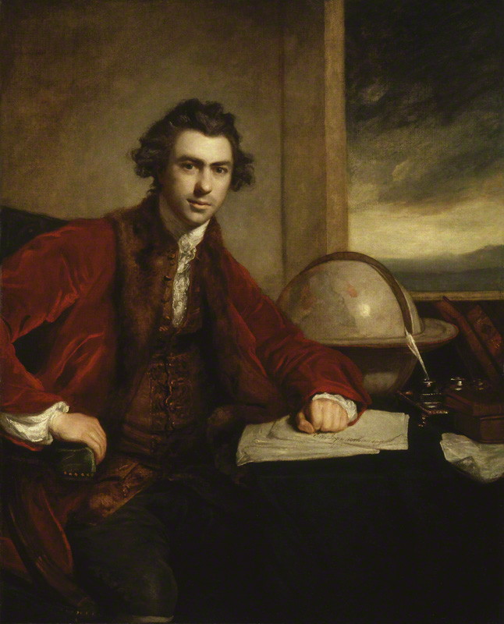
Thematic
This week we would have been starting our new topic – Littleover and Beyond.
This week we will be looking at where Derby is in relation to other cities in England.
Look at a map of Great Britain and identify where Derby is. Which other city names do you recognise?
Try to place as accurately as you can as many cities as you can remember on the blank UK map.
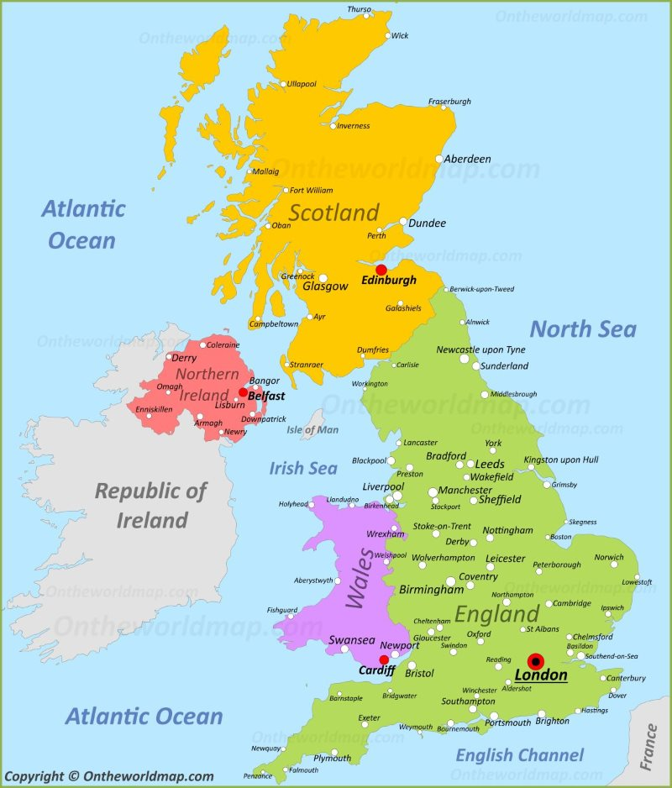
Art
This half term we will be learning about another famous artist – Seurat.
L2L activity: Read the presentation about Seurat and try to remember as much as you can. Afterwards, create a mindmap about what you can remember. You can re-read the presentation to help your memory but you cannot copy from it!


